D**ATA SCIENCE & MACHINE LEARNING**

**LAB CYCLE 3**

**1. Mathplotlib**

**Demonstrate creating various types of charts and plots using functions in mathplotlib library**

**1. Sarah bought a new car in 2001 for $24,000. The dollar value of her car changed each year as shown in**

**the table below.**

**Value of Sarah&#39;s Car**

**Year Value**

**2001 $24,000**

**2002 $22,500**

**2003 $19,700**

**2004 $17,500**

**2005 $14,500**

**2006 $10,000**

**2007 $ 5,800**

**Represent the following information using a line graph with following style properties**

**• X- axis - Year**

**Y –axis - Car Value**

**• title –Value Depreciation (left Aligned)**

**• Line Style dashdot and Line-color should be red**

**• point using * symbol with green color and size 20**

**Subplot() provides multiple plots in one figure.**

**Program**

import matplotlib.pyplot as plt

import numpy as np

xpoints = np.array([2001, 2002, 2003, 2004, 2005, 2006, 2007])

ypoints = np.array([24000, 22500, 19700, 17500, 14500, 10000, 5800])

plt.title("Value-Depreciation", loc = 'left')

plt.plot(xpoints,ypoints, '-.r', marker ='*', ms = 20, mec = 'g', mfc = 'g')

plt.show()

**Output**

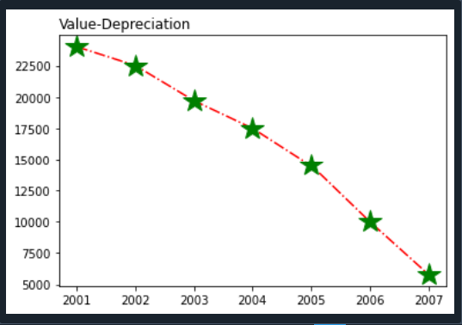

**2. Following table gives the daily sales of the following items in a shop**

**Day Mon Tues Wed Thurs Fri**

**Drinks 300 450 150 400 650**

**Food 400 500 350 300 500**

**Use subplot function to draw the line graphs with grids(color as blue and line style dotted) for the**

**above information as 2 separate graphs in two rows**

**a) Properties for the Graph 1:**

**• X label- Days of week**

**• Y label-Sale of Drinks**

**• Title-Sales Data1 (right aligned)**

**• Line –dotted with cyan color**

**• Points- hexagon shape with color magenta and outline black**

**b) Properties for the Graph 2:**

**• X label- Days of Week**

**• Y label-Sale of Food**

**• Title-Sales Data2 ( center aligned)**

**• Line –dashed with yellow color**

**• Points- diamond shape with color green and outline red**

**Program**

import matplotlib.pyplot as plt

import numpy as np

#plot 1

x = np.array(['mon', 'tues', 'wed', 'thu', 'fri'])

y = np.array([300, 450, 150, 400, 650])

plt.subplot(2, 1, 1)

plt.title("Sales Data 1", loc = "right")

plt.xlabel("Days of week")

plt.ylabel("Sale of Drinks")

plt.plot(x,y, color = 'cyan', linestyle = 'dotted', marker = 'H', mec = 'black', mfc = 'm')

plt.grid(color = 'blue', linestyle = 'dotted')

#plot 2

x = np.array(['mon', 'tues', 'wed', 'thu', 'fri'])

y = np.array([400, 500, 350, 300, 500])

plt.subplot(2, 1, 2)

plt.title("Sales Data 2")

plt.xlabel("Days of week")

plt.ylabel("Sale of Food")

plt.plot(x,y, color = 'y', linestyle = '--', marker = 'D', mec = 'r', mfc = 'g')

plt.grid(color = 'blue', linestyle = 'dotted')

plt.subplots_adjust(top=2.5,

bottom=1.5,

wspace=0.4,

hspace=0.4)

plt.show()

**Output**

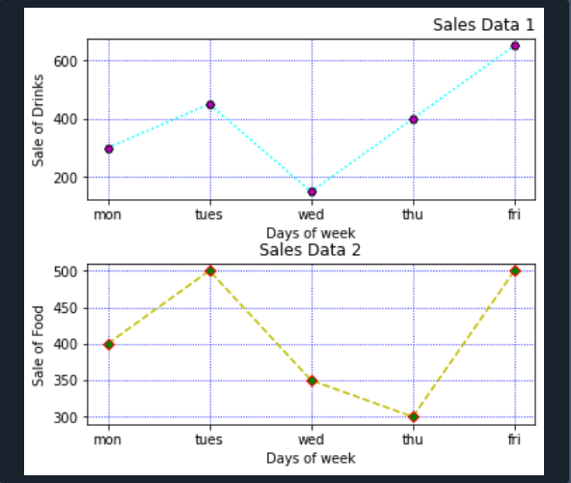

**3. Create scatter plot for the below data:(use Scatter function)**

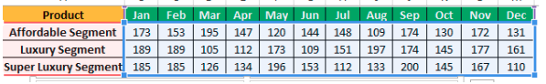

**Create scatter plot for each Segment with following properties within one graph**

**• X Label- Months of Year with font size 18**

**• Y-Label- Sales of Segments**

**• Title –Sales Data**

**• Color for Affordable segment- pink**

**• Color for Luxury Segment- Yellow**

**• Color for Super luxury segment-blue**

**Program**

import matplotlib.pyplot as plt

import numpy as np

plt.xlabel("Month of year", fontsize = 18)

plt.ylabel("Sales of Segments", fontsize = 18)

plt.title("Sales Data")

x = np.array(["jan", "feb", "mar", "apr", "may", "jun", "july", "aug", "sep", "oct", "nov", "dec"])

afseg = np.array([173, 153, 195, 147, 120, 144, 148, 109, 174, 130, 172, 131])

plt.scatter(x, afseg, color = "hotpink")

x = np.array(["jan", "feb", "mar", "apr", "may", "jun", "july", "aug", "sep", "oct", "nov", "dec"])

lseg = np.array([189, 189, 105, 112, 173, 109, 151, 197, 174, 145, 177, 161])

plt.scatter(x, lseg, color = "y")

x = np.array(["jan", "feb", "mar", "apr", "may", "jun", "july", "aug", "sep", "oct", "nov", "dec"])

slseg = np.array([185, 185, 126, 134, 196, 153, 112, 133, 200, 145, 167, 110])

plt.scatter(x, slseg, color = "b")

plt.show()

**Output**

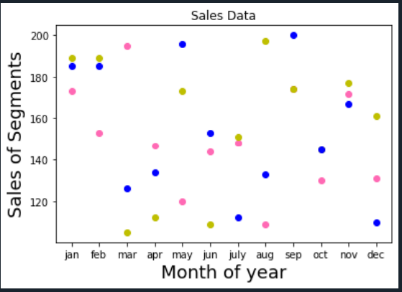

**4. Display the above data using multiline plot( 3 different lines in same graph)**

**• Display the description of the graph in upper right corner(use legend())**

**• Use different colors and line styles for 3 different lines**

**Program**

import matplotlib.pyplot as plt

x1 = ['jan','feb','mar','apr','may','jun','jul','aug','sep','oct','nov','dec']

x2 = [173, 153, 195, 147, 120, 144, 148, 109, 174, 130, 172, 131]

plt.plot(x1, x2, color = 'hotpink', label = 'line 1', ls = '-.')

y1 = ['jan','feb','mar','apr','may','jun','jul','aug','sep','oct','nov','dec']

y2 = [189, 189, 105, 112, 173, 109, 151, 197, 174, 145, 177, 161]

plt.plot(y1, y2, color = 'y', label = 'line 2', linestyle = 'dashed')

z1 = ['jan','feb','mar','apr','may','jun','jul','aug','sep','oct','nov','dec']

z2 = [185, 185, 126, 134, 196, 153, 112, 133, 200, 145, 167, 110]

plt.plot(z1, z2, color = 'blue', label = 'line 3',linestyle = 'dotted')

plt.xlabel("Month of year", fontsize = 18)

plt.ylabel("Sales of Segments", fontsize = 18)

plt.title("Sales Data")

plt.legend()

plt.show()

**Output**

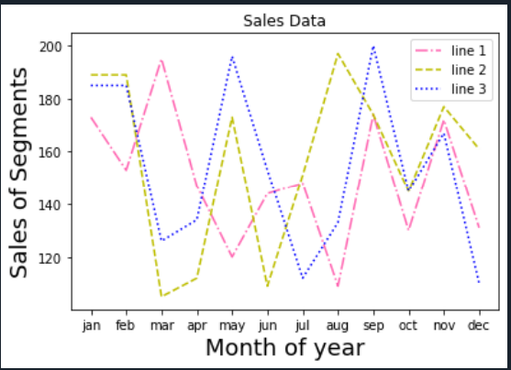

**5. 100 students were asked what their primary mode of transport for getting to school was. The results of**

**this survey are recorded in the table below. Construct a bar graph representing this information.**

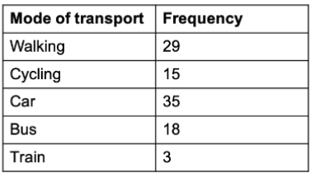

**Create a bar graph with X axis -mode of Transport and Y axis ‘frequency’**

**Provide appropriate labels and title**

**Width .1, color green**

**Program**

import matplotlib.pyplot as plt

import numpy as np

plt.title("Student Transport Data")

plt.xlabel("mode of transport")

plt.ylabel("frequency")

x = np.array(["Walking", "Cycling", "Car", "Bus", "Train"])

y = np.array([29, 15, 35, 18, 3])

plt.bar(x,y, color ="g", width = 0.1)

plt.show()

**Output**

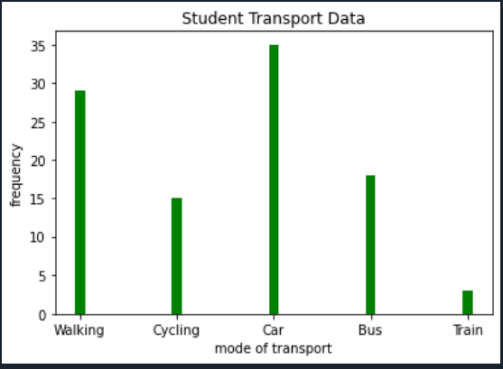

**6. We are provided with the height of 30 cherry trees.**

**The height of the trees (in inches): 61, 63, 64, 66, 68, 69, 71, 71.5, 72, 72.5, 73, 73.5, 74, 74.5, 76, 76.2,**

**76.5, 77, 77.5, 78, 78.5, 79, 79.2, 80, 81, 82, 83, 84, 85, 87.Create a histogram with a bin size of 5**

**Program**

import matplotlib.pyplot as plt

height = [61, 63, 64, 66, 68, 69, 71, 71.5,

72, 72.5, 73, 73.5, 74, 74.5, 76,

76.2,76.5, 77, 77.5, 78, 78.5, 79,

79.2, 80, 81, 82, 83, 84, 85, 87]

plt.hist(height, edgecolor="r",bins=5)

plt.show()

**Output**

